Francesco

Galassi

[Email → f.galassinewcastle.ac.uk](mailto:f.galassinewcastle.ac.uk)

First year student at Newcastle University, born in Italy but actually living in Newcastle studying [Computing Computer Science with Industrial Placement (Game Engineering)](https://www.ncl.ac.uk/undergraduate/degrees/g451/#coursedetails).

# SKILLS:

JAVA, JUNIT

HTML + CSS+ JAVASCRIPT AND WEBSITE USABILITY ANALYSIS

ASSEMBLY

ECDL

MATHS, PROBLEM-SOLVING AND TIME MANAGEMENT

UNITY 3D

C++, C#, AR APP

LANGUAGE SKILLS: ITALIAN / ENGLISH

SELF-TAUGHT SKILLS (ANDROID STUDIO, ADOBE SUITE)

TEAMWORKING, PRESENTING AND ANALYZING SKILLS

Java & JUnit

Since coding is the main module in a computer degree, this year Java has been the main programming language I learnt. Java is one of the most popular programming languages and required for a job placement. It is so versatile; you can create programs and app for mobile and for the web too.

Project 1 HANDLE STUDENT’S MARKS AND CREDITS IN JAVA:  
During term 1 I designed a program in java to manage student’s marks and credits at the university. The request was that the school of computer science had commissioned to write a software to keep a track of Stage 1 student marks.

As an example, I attach a piece of code:

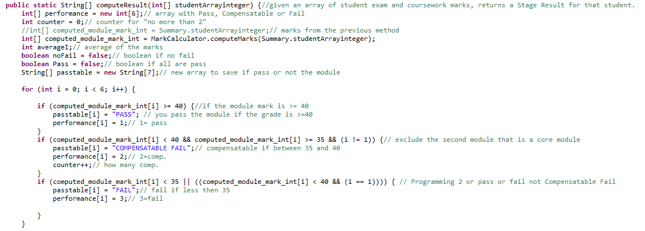

Figure 1Project 1 Sample

That has been the first software I created at all and it was simple without knowing advanced techniques of defensive programming and good practices.

For more details, you can find the documentation I wrote for that project attached [HERE](Project%201/Project1_documentation_Francesco_Galassi.docx).

I put the link because a screenshot could not be readable.

Project 2 DESIGN HOTEL BOOKING SYSTEM IN JAVA:  
During term 1 I have designed a hotel booking software in Java.

The request was to build an online hotel management system, designing and implementing a system for storing and calculating some key information about a hotel such as a name and some rooms, the number of beds in a room and the size of the beds.

This coursework was more challenging than the previous one but it had not too many features, it interacted with the user through a simple command-line interface using Scanner and “println” statements. The hotel system was presented with a test class.

Here there are attached the screenshots of the java files, click to read them as a text file.

|  |  |
| --- | --- |
| Figure 2 HotelTest | Figure 3 Bed |
| Figure 4 Room | Figure 5Hotel Report |
| Figure 6 Hotel Configure | Figure 7 Hotel |

PROJECT TO DEBUG WITH JUNIT

Since writing code for a program should be supported by appropriate tests, I have also learnt testing and debugging techniques for a Software Engineering Professional assessment in order to be able to handle errors and bugs for all the future programs.

The software to being tested was a word game and for that coursework, I produced a report available [HERE](Software%20Engineering%20Professional/GalassiTnD.docx).

Project 3 PROGRAM TO MANAGE STUDENT REGISTRATION AT UNI

During semester two in a Project assessment, I created a java program to register and amend students in a university system.

This piece of coursework was the most advanced so far since it was based on the practice of advanced programming techniques including overriding methods, interface-based hierarchies, late binding, use of factories and defensive programming.

The code is available only on request.

Web Design and Development + Usability Analysis

After studying and practising new languages such as HTML, CSS and JavaScript, some of the basic programming language for developing websites, in this semester two I created a Site for an assessment, following directions of the coursework.

The topic of the website was an explanation of Sign Languages.

The project expected the creation of two websites one in plain XHTML and one with the Cascading Style Sheets. Both the pages are attached here: [XHTML](Web%20Design%20and%20Development/bsl-XHTML.html) [CSS](Web%20Design%20and%20Development/bsl-CSS.html).

Now another project is running but the files are available only on request.

Moreover, in order to have a wide range of skills, I learnt to evaluate the usability of a website, following the guidelines that in the early 90's Jakob Nielsen and Rolf Molich created evaluating usability with their heuristic evaluation, a method that identifies design problems.

In this case, the heuristic evaluation is applicable to the Blackboard system.

For this coursework, I wrote a report available [HERE](Software%20Engineering%20Professional/CSC1023_Usability_Report_Francesco_Galassi.docx).

Assembly

During this year, I also learnt Assembly, another programming language creating four programs after having studied computer architecture in semester 1.

The first semester I studied some historical facts for an architecture background and computer architecture with raspberry pi understanding how every piece of technology physically works with gates and the hardware.

On semester 2, I started learning Assembly language using the raspberry pi creating four pieces of coursework. For the first one, I had to write a subroutine that generates three check bits assuming even parity. Passing a 4-bit word, the output should have been a 6-bit word.

The second coursework required me to write a subroutine that corrects a single corrupted bit assuming even parity.

The third was more complex and required me to write a subroutine called “generate16” which generates five check bits assuming even parity. A 16-bit word is passed and the output of the program is a 21-bit word.

The last coursework was a subroutine that corrects a single corrupted bit returning a 16-bit word from a 21-bit word.

The code is available only on request.

ECDL

During High School, after completing the ECDL course and after passing all the exams, I achieved the European Computer Driving License.

It is a worldwide-recognized computer literacy certification program that according to the definition given to the main website, it provides students with the IT skills and abilities needed to build on existing knowledge, motivate further learning, and improve their employability in a wide range of fields and industries.

The modules I took are:

1. Online Collaboration
2. IT Security
3. Using Databases
4. Presentation
5. Online Essentials
6. Spreadsheets
7. Word Processing
8. Computer Essentials
9. IT Security

My Skills Card is available [HERE](ECDL/Certificato_ECDL_Profile_GALASSI.pdf)

Maths, Problem-Solving and Time Management

When choosing which secondary school to attend I decided on a high school specializing in scientific subjects to focus on mathematics, algebra and physics. In particular, I selected the IT stream that included computer-oriented problem solving.

I successfully graduated from High School with a grade of 95/100 in which my Maths Exam result was of 14 out of 15.

These results met my expectation so I could enter the Newcastle University that was my greatest ambition.

This is a comparison table to compare the academic equivalence

|  |  |
| --- | --- |
| **A-level** | **Comparable offer** |
| AAA | 95 |

Table 1 from https://www.brighton.ac.uk/international/study-with-us/your-country-info/italy-equivalencies.aspx

Certificate [HERE](Graduation%20High%20School/CERTIFICATO%20DI%20MATURITA%20GALASSI%20FRANCESCO.pdf) (personal and sensitive data from High School for the University application).

During the 5 years of High School, I learnt how to master time management skills and techniques to do my best with perfect timing and all the courses were problem solving based to give the students all the tools to face to every kind of problem.

These skills are useful to face up to the university life indeed I have never submitted a piece of coursework late.

Unity 3D for Gaming

Last year of High School, I had the chance to do a month-long internship at Red Frog Digital, a company based in Manchester and specialized in the development of Augmented Reality Applications. It was an excellent opportunity to discover the world of object-oriented programming, game design and development.

I tried to create and animate objects and characters before placing them in a first-person shooter game using the ray casting technique.

I produced a presentation available [HERE](Unity%203D/Francesco%20Galassi%20Alternanza.pptx) (data from High School projects) in which I presented all the work I did showing also the main features of Unity 3D and explaining (text in Italian) pieces of code I produced in C#.

C++, C#, AR App

During High School, I studied basics of C++ programming language learning how programming works and general knowledge such as loops if clauses and definition of a function.

Moreover, during the last year of school I started learning C# to use it with Unity 3D and for my degree thesis, I proposed an AR App developed using Vuforia. The main topic of my theses was an analysis of some aspects of the evolution of humanity with the technology analyzing the vision of Elon Musk.

The app I developed works by scanning the pages of my writing and it shows photo, video and multimedia content as explanation. I am attaching some code sample from the app:

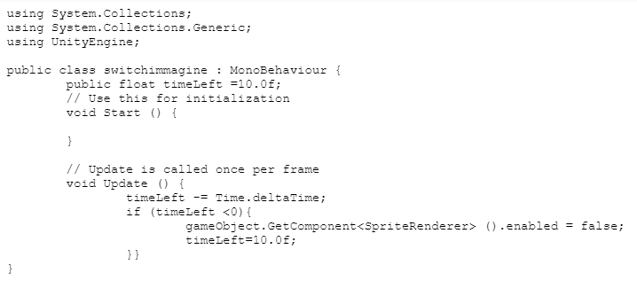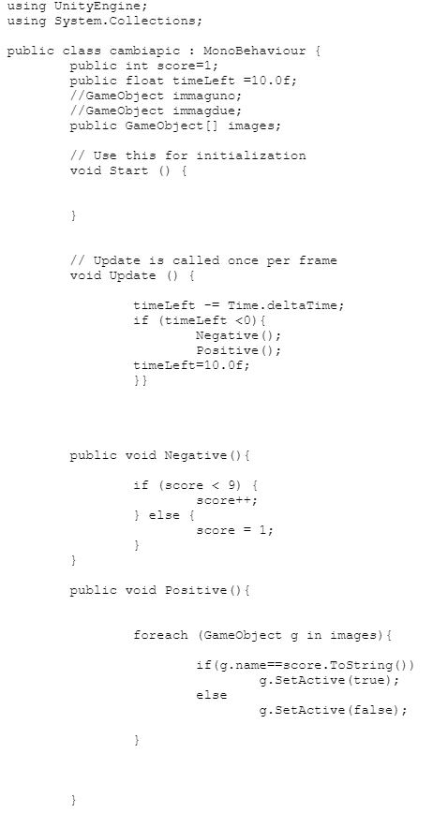

The app (for Android only) is available online to download [HERE](https://drive.google.com/drive/folders/0B74BLUIowrdsbXp3MUYwaUszeGc?usp=sharing).

Language Skills: Italian / English

I was born in Italy so Italian is my native language but, I started studying English from primary school.

Knowing more than one language is a fundamental aspect today because more often people travel around the world for business or for pleasure.

Therefore, in middle school, I started spending some weeks during the summer to learn and practice English fluency attending colleges in the UK.

In September 2011, I studied at Bedales School, Certificate [HERE](English%20Language/bedales.jpg).

In August 2012, I attended a college in Bath, Certificate [HERE](English%20Language/Bath.jpg).

In August 2013, I attended a school in Liverpool, Certificate [HERE](English%20Language/Liverpool.jpg).

In August 2015, I have been living in Wollongong with an Australian boy for almost a month for an exchange, Certificate [HERE](English%20Language/Australia.jpg).

Then In May 2016, I decided to take the First and the First Certificate in English (FCE) and I passed it with the overall score of 167, Certificate [HERE](English%20Language/FCE.jpg).

In August 2016, I have been to study in a college in Dublin, Certificate [HERE](English%20Language/Dublin.jpg).

Then since I wanted to meet the requirement for the application at the university, while I was doing the High School exam, between the second and the third test, I took the IELTS (according to the official website, the high stakes English test for international study, migration and work) and I passed it with an overall score of 7.

IELTS Certificate is available [HERE](IELTS/IELTS%20Francesco%20Galassi.pdf)

All these certifications are a proof of my attitude and my availability at travelling that it is a necessary skill for an international career.

Self-Taught Skills (Android Studio, Adobe Suite)

In Computing, every software developer must have flexibility and adaptability as skills because since it is impossible to learn and know every existing programming language, the coder should be able to pass from a programming language to another with no difficulties.

Since high school, I started to learn and study to use some software, IDE and tools just because they were some of my passions and hobbies.

I am able to use some tools of the Adobe Creative Suite because I like editing photos and videos.

I am able to use Photoshop, Illustrator, InDesign and After Effects.

[HERE](https://drive.google.com/open?id=0B74BLUIowrdscVNOTms3bU5XN3c) is possible to find a book trailer I made in a High School teamwork.

This year, I joined the NUCATS, society of computing and in their event, I learnt how to use Android studio (screen attached at the end) and I also took part in a competition to win a Google home mini and I came in the second place.

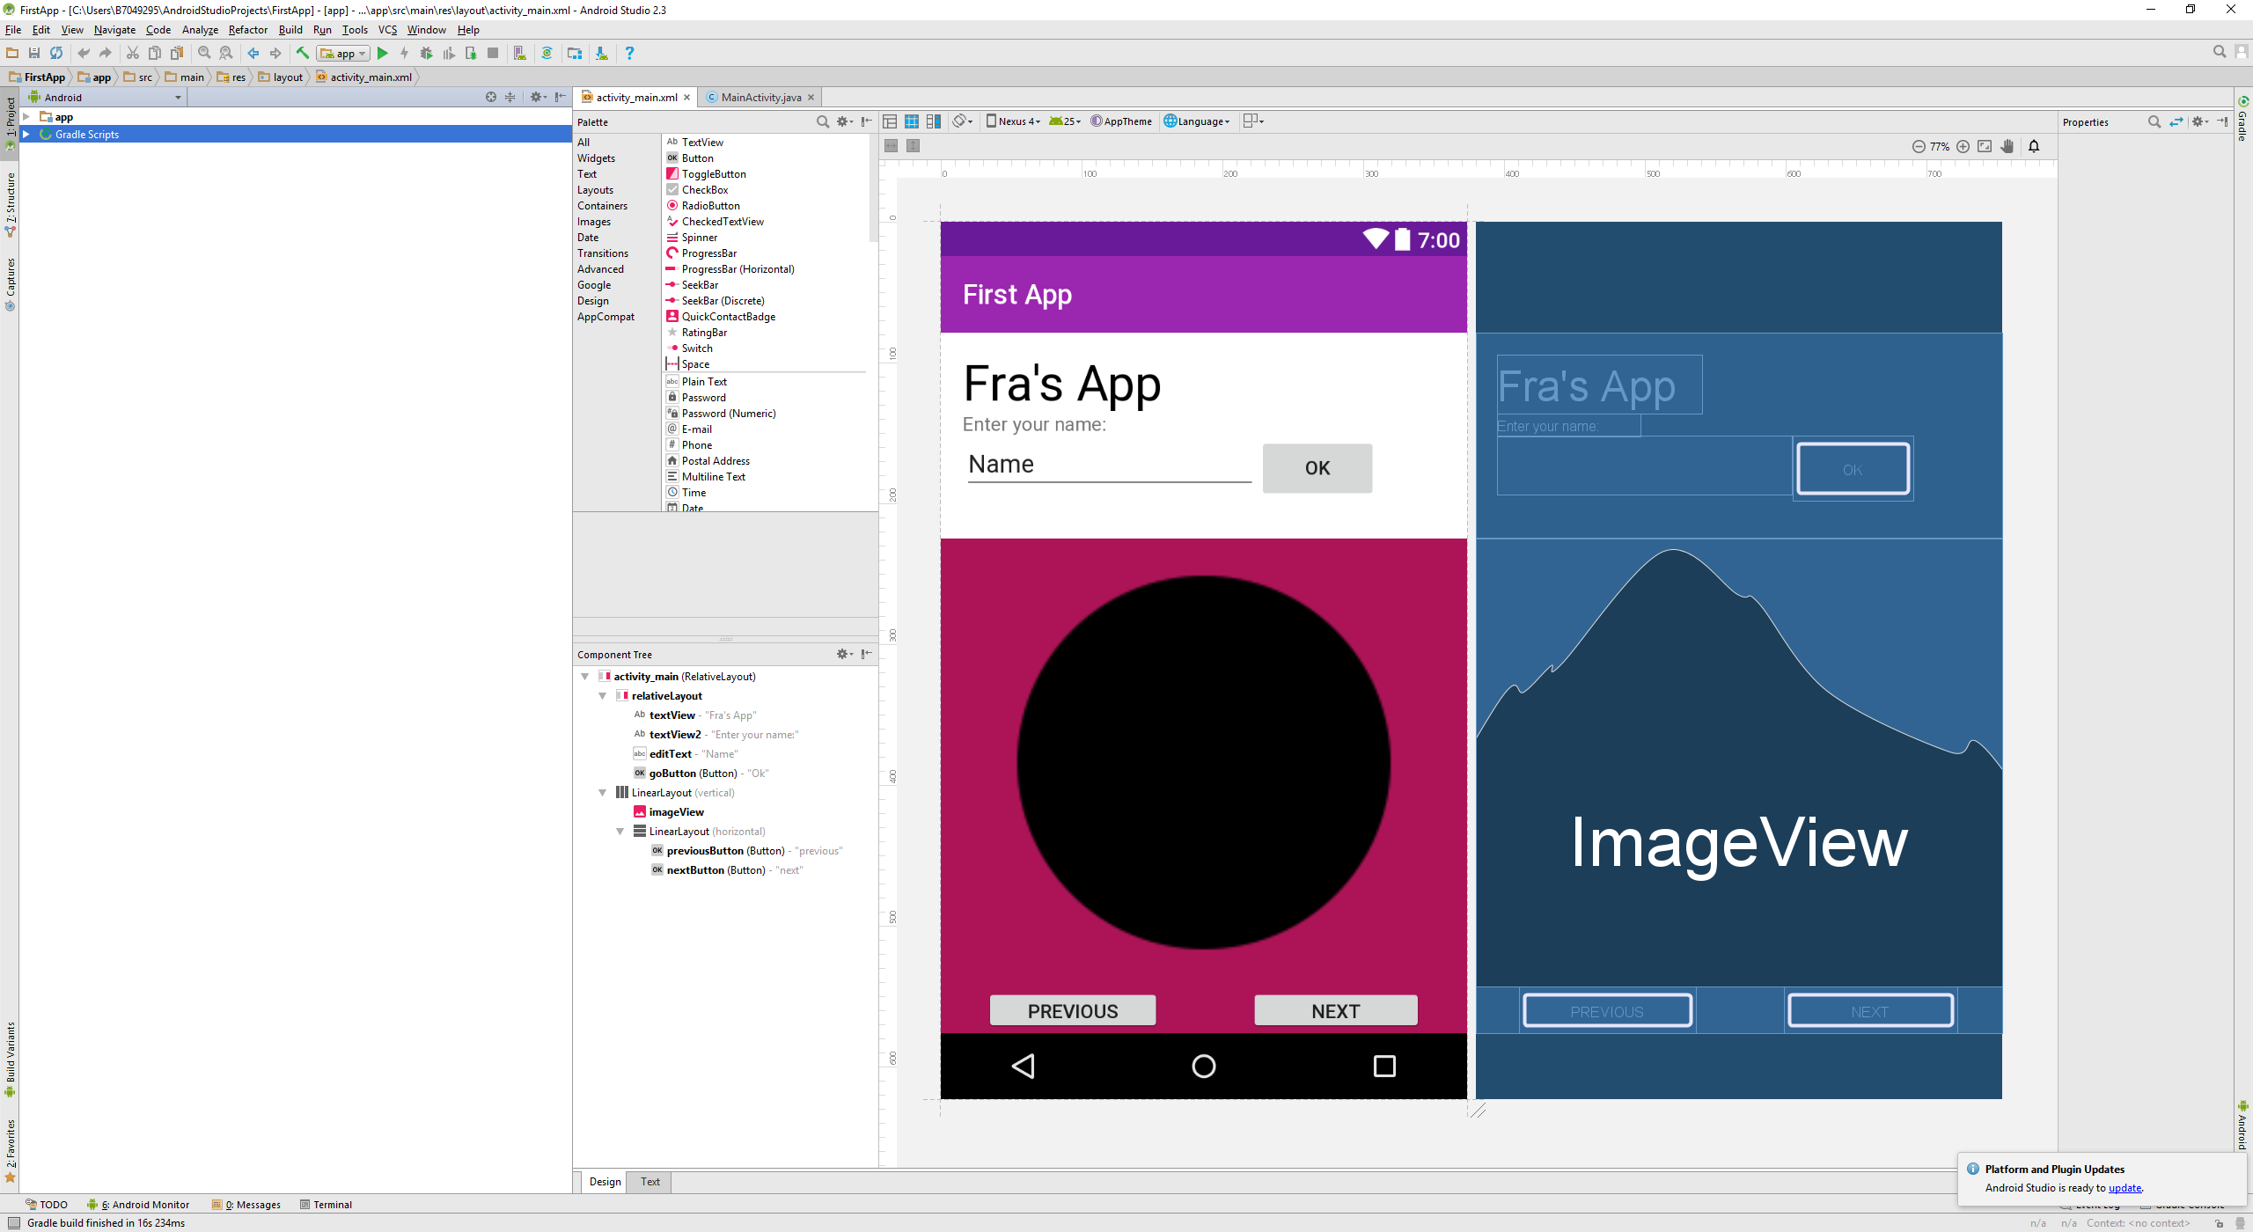

TEAMWORKING, PRESENTING AND ANALYZING SKILLS

During this year at university, I have not only developed coding skills but also I have developed people skills and relationships with my colleague e.g. arranging meetings, make plans share ideas and coworking.

I have done some coursework with my colleagues, for example, we prepared a couple of presentation about historical facts of famous people in computing and programming languages.

Presentation skill is important for marketing if in need of presenting a product or for conferences. Knowing how to talk in public is also important to create relationships between people and to give the right motivation to your team.

Speaking is not the only skill required for interacting with other people, so this year I also practised academic writing.

This second semester I wrote a literature review about Human-Computer Interaction learning how to find good and right sources and combine the work that people have already done with the one researchers are still doing.

The literature review is available only on request.